***Cybersecurity Threat Analysis: Examining Real Attacks and Strengthening Defense Strategies***

1.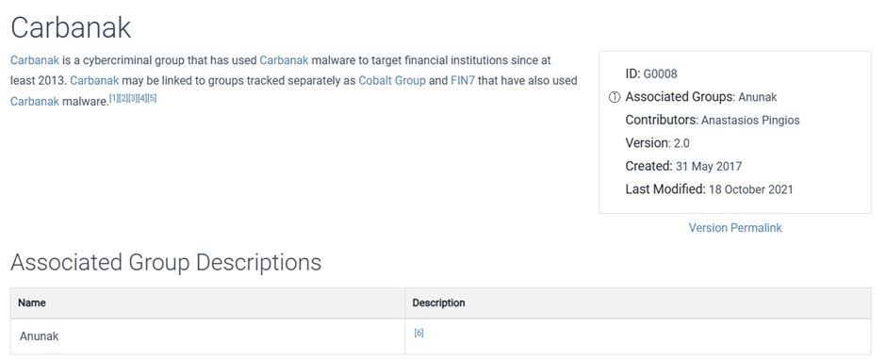

2.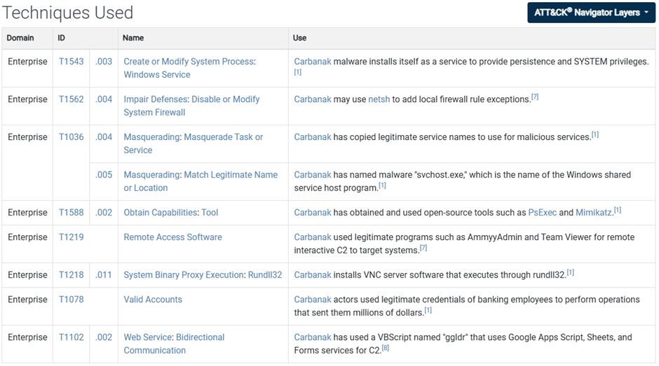

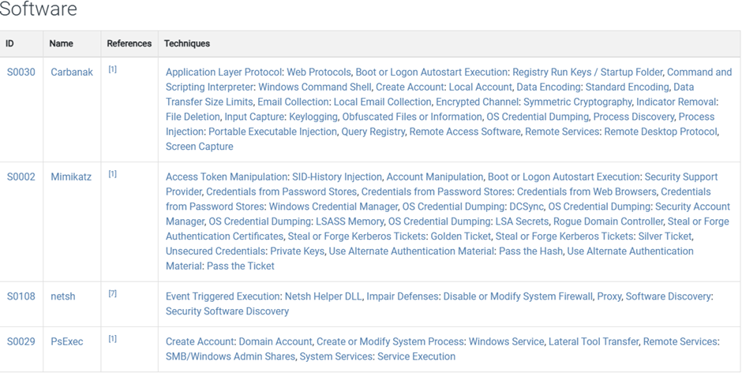

**Enhancing Monitoring and Detection:**

* Implementing **SIEM (Security Information and Event Management)**.
* **Behavioral monitoring**.

**Strengthening Authentication Measures:**

* **Multi-factor authentication (MFA)**.
* **Privileged access management**.

**Improving Endpoint Protection:**

* **Regular updates and patches**.
* **Advanced endpoint protection solutions**.

**Employee Education and Awareness:**

* **Continuous training programs**.
* **Attack simulations**.

**Enhancing Network Security Measures:**

* **Network segmentation**.
* **Firewalls and IDS/IPS (Intrusion Detection and Prevention Systems)**.

**Collaboration and Information Sharing:**

* **Partnerships with other organizations**.
* **Participation in security communities**.